**Experiment: 150nm pMOS and nMOS Characteristics**

**PART-A**

**Aim:**

To implement a pMOS transistor and analyze its output and transfer characteristics.

**Tool Used:**

LTspice

**Theory:**

PMOS transistors operate by creating an inversion layer in an n-type transistor body. This inversion layer, called the p-channel, can conduct holes between p-type "source" and "drain" terminals. The p-channel is created by applying a negative voltage to the third terminal, called the gate. 150nm represent the minimum feature size of the NMOS transistor.

**Circuit Schematic:**

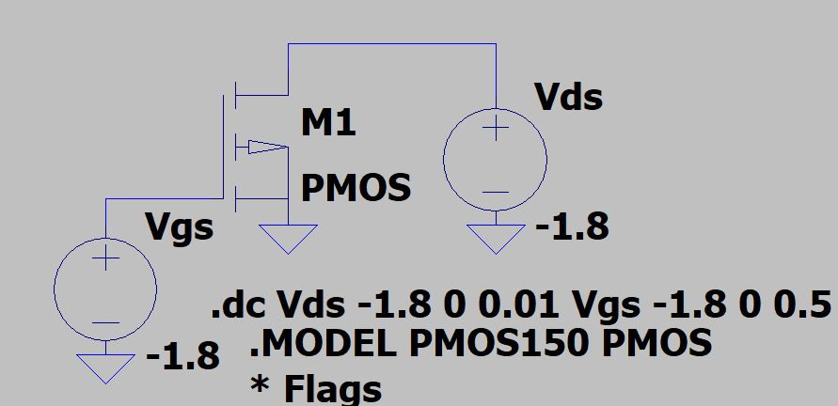

**Output Waveforms:**

Output characteristics (Vds vs. Id)

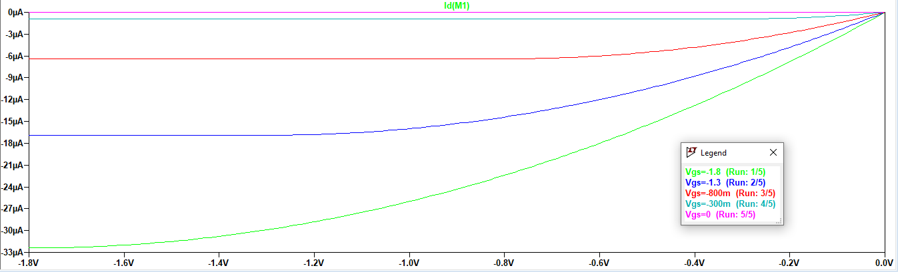

Transfer characteristics (Vgs vs. Id)

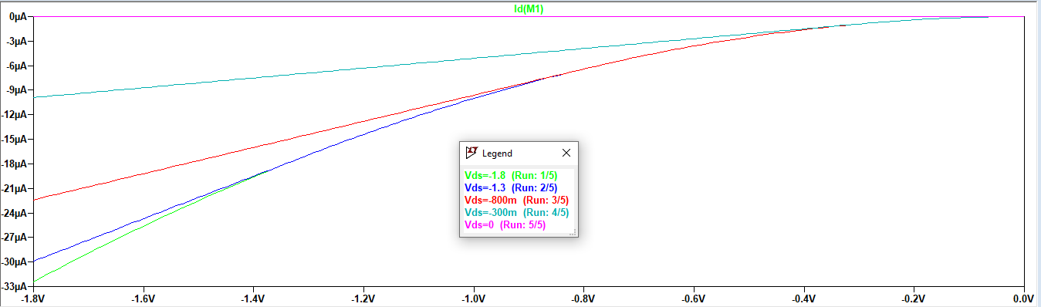

**Result:**

The circuit is stimulated using 150nm technology node and the output and transfer characteristics are visualized.

**PART-B**

**Aim:**

To implement an nMOS transistor and analyze its output and transfer characteristics.

**Tool Used:**

LTspice

**Theory:**

nMOS transistors operate by creating an inversion layer in a p-type transistor body. This inversion layer, called the n-channel, can conduct electrons between n-type "source" and "drain" terminals. The n-channel is created by applying voltage to the third terminal, called the gate. 150nm represent the minimum feature size of the NMOS transistor.

**Circuit Schematic:**

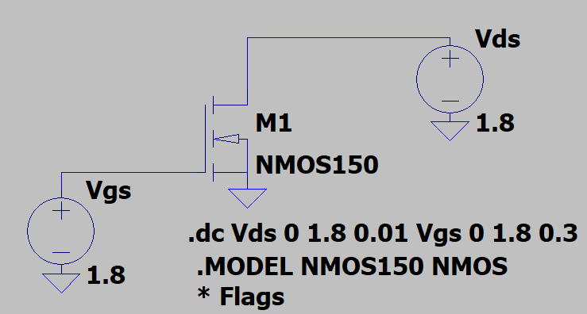

**Output Waveforms:**

Output characteristics (Vds vs. Id)

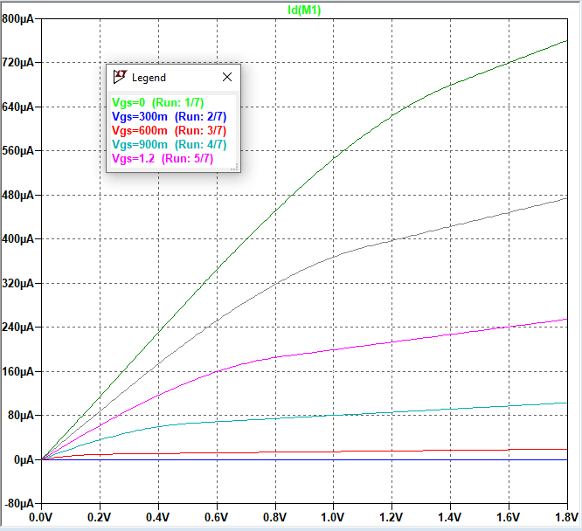

Transfer characteristics (Vgs vs. Id)

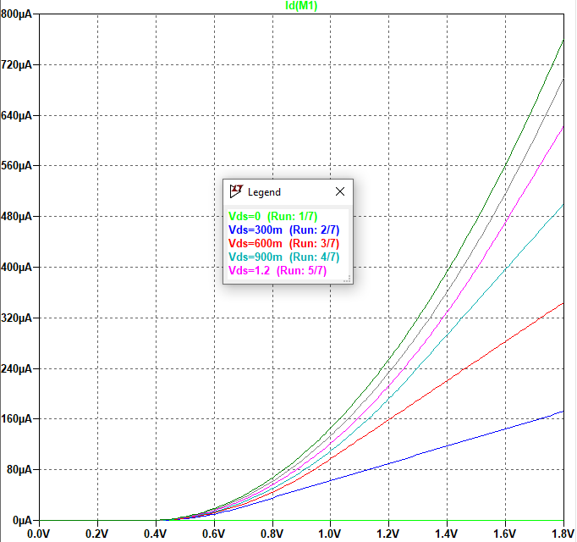

**Result:**

The circuit is stimulated using 150nm technology node and the output and transfer characteristics are visualized.